Getting started with Flask

To build our microservices we will be using the python library Flash. This can be installed on your machine by issuing the following pip command:

*pip install flask*

Next download the file on the Moodle page titled *tinyserver.py.* Once you have done this, open up a command prompt and issue the following command to set the current flask app to be the *tinyserver.py* file:

*SET FLASK_APP=tinyserver.py*

To run the server simply issue the following command:

*python -m flask run*

You will then see the following output telling you the service has now started.

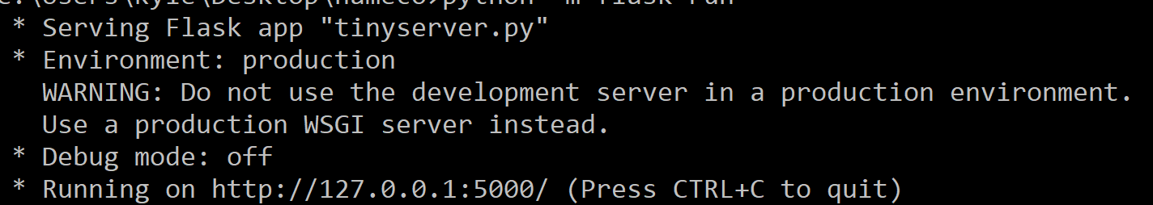

To view the web server, open the following link in a web browser.

<http://127.0.0.1:5000/>

You will then see the following output from the tiny server:

